April - Maple Hills PTA Newsletter

Bringing Our School Community Together
The Chirp!
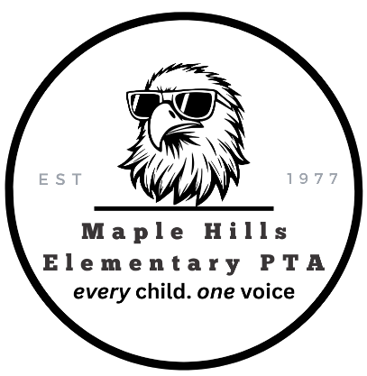
Important PTA Event Dates
April 4
Infinity Farm Egg Hunt & Farm Day
Eagle Reader on-line submission close
April 7
Eagle Reader Clubhouse
April 8
Eagle Choir – Spring Concert
April 13-17
No School - Spring Break
April 19 – May 1
Read-a-Thon
April 22
PTA General Membership Meeting
Get PTA Events emailed to your inbox. Sign up: MapleHillsPTA.Com

Dear Maple Hills, Elementary Families,
Thank you to everyone who has stepped up to volunteer and serve on next year’s PTA board. Your time and dedication make a meaningful difference for our students, teachers, and school community. We are still welcoming additional volunteers—many hands truly do make light work, and every bit of support helps us do even more.
Looking ahead, we’re excited to share a change in our fundraising approach. This year, we will be moving away from the auction and introducing a Read-a-Thon as our primary fundraiser. We hope this new event inspires a love of reading while helping us meet our goals. When it kicks off, we encourage you to participate, donate if you’re able, and share with friends and family.
Thank you for being such an important part of our community.
Warmly,
Heather Stiles
Maple Hills PTA President
2026-2027 PTA Elected Position Nominations Update
🗳️ PTA General Membership Meeting & Elections
Join us for our upcoming PTA General Membership Meeting: Wednesday, April 22nd | 7:00 PM
(We’d love to see you in person. Zoom link available upon request)
During this meeting, we will be voting on our elected PTA positions for the 2026–2027 school year.
🗳️ Elected Board Nominations (2026–2027)
The following slate of nominees will be presented for a vote:
- President: Kirby White
- Vice President: Amanda Heinz
- Secretary (Co): Erica Sweany & Maggie Schulze
- Treasurer: Rhett Hadman
All PTA members are encouraged to attend and participate in the election.

We Still Need PTA Team Volunteers
We also have a number of important appointed positions that are essential for our PTA to function and support school programs. If you’re interested in helping, please email us for a current list of open roles.
Without enough volunteers to fill key positions, we will need to scale back or eliminate certain events and programs based on available support.
Your involvement makes a difference—thank you for supporting our school community!

Restaurant Nights to Support MH
Our last Restaurant Night of the School Year!
Ben & Jerry’s – Thursday, May 21 | 12:00-9:00
1011 NE High St, Suite 103, Issaquah, WA 98029
Beach Day Spirit Day is happening the same day! Wear your beachy best and stop by Ben & Jerry’s to enjoy a treat and support our school. Every scoop makes a difference!

Spring Into Reading:
Read-a-Thon & Library Events
📚 Read-a-Thon (April 19 – May 1)
Our biggest fundraiser is coming! Watch for details and get ready to read, participate, and share.
📸 Reading Photos Wanted
Send spring break photos of your student reading to be featured in the library’s digital frame.
📖 Book Fundraiser @ Island Books (April 19)
Shop for books and support Maple Hills—stop by in the morning!
🎨 Bookmark Contest
Kicks off next week; students can work on entries after break. Forms go home the week of April 6.
✍️ Author Visit: Ellie Peterson (April 23)
Send books by April 22 with student name, teacher, and autograph details for signing.
🎉 Library Fun
Enjoy special activities during library time throughout the Read-a-Thon!

🌸 Fuchsia Basket Sale – Ends April 7!
Don’t miss your chance to order beautiful hanging fuchsia baskets—just in time for spring!
Orders close April 7, so be sure to scan the QR code to purchase yours today.


Fundraising Update
Behind the scenes, our fundraising team is working hard to fund PTA programs and events, because every penny adds up.
- Tipsy Cow $521
- Reign soccer $140
- Jay Berry's $318.26
- Drum Roll $115
- Chipotle $83.11
- Poinsettias $906.20
- Regal $60
- Dave and Busters $110
- Mod pizza $199.34
- Thunderbird hockey $650
- Dough Zone $100
- Tapatios $350
- Bingo for Grown Ups $3,810
- Sno King $223
- SnapDoodle gifts $139.33
- Arena Sports $199.95
- Red Robin $171.25

Read-A-Thon 4/20-5/1/2026.
Our Goal: To raise money for our school library and Eagle Reader program. More to follow soon!
Questions? Email: Fundraising@MapleHillsPTA.com

